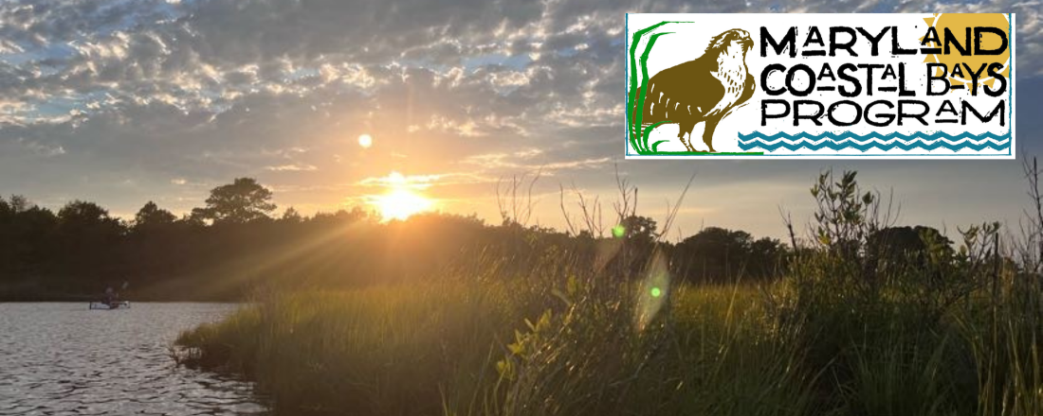

September Newsletter

A Note from the Director

  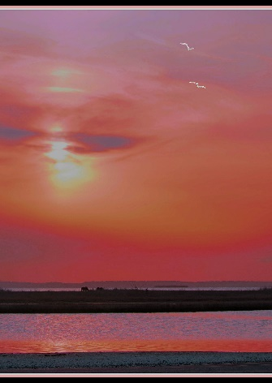
  Making the Magic Happen
  Every once in a while, the magic happens. And thank goodness it does. Otherwise, things can look a little bleak.
  The magic happened for me last week on an incredibly beautiful September day in Chincoteague Bay. Cerulean blue skies. The water so clear you could see a good 4 – 6 feet down to the bottom where the eel grasses swayed in the currents. You could clearly see crabs and fish moving within the undulating grasses and then the magic. A diamondback terrapin swims two feet below the surface. She didn’t see me in the boat above as I watched her swim by doing what a terrapin was put on this earth to do. For a critter that looks so awkward and clumsy on land, she certainly has an elegance and grace when she’s in her

element. Yes, that’s magic. It still happens here and every once in a while, we get to see it.

Underwater grasses, otherwise known as submerged aquatic vegetation (SAV) provide habitat for so many species it would be difficult to name them all. SAVs pump oxygen into the waters, help dissipate wave energy, and cause sediments to drop out. SAVs are the lifeblood of our waterways but they are not doing so well. We haven’t had a good stand of SAVs in the northern part of the Coastal Bays in ten years. And grasses in the southern bays are diminishing. Our SAV survey for 2022 shows continued decline of grasses in Sinepuxent, Newport and Chincoteague Bays. This is not the news we were hoping to hear.

Why are they diminishing? There are several reasons but mostly it’s related to the quality of the water. High turbidity and excess nutrients are the main culprits. Basically, it’s what we do on the land that has such an effect on our tidal waterways. This is a difficult problem to wrap our arms around because there are so many sources. These nutrients and sediments are coming from everywhere. The atmosphere, the shoreline, the farm fields, the wastewater treatment plants, the groundwater, every little town and every little ditch and channel that runs water from our inland areas to the tidal waters.

We know things can be better. It’s a long journey and it takes commitment, time and effort, but we can improve the quality of our waterways by improving how we take care of our land. Recently, the Chesapeake Bay has seen an uptick in SAVs. Is this a result of the nearly 40 years of effort to establish stream buffers, restore wetlands, install agricultural best management practices among others? Maybe so. The fact is, we must make the same efforts here in our easternmost watershed if we want to see similar improvements.

While our recent news regarding underwater grasses is not good, I hope it strengthens our resolve to address the issues like stormwater runoff and land management and other tough issues. If so, maybe that magic won’t be such a remarkable thing. Maybe it will become the norm.
Kevin Smith
Executive Director

Celebrating National Estuary Week

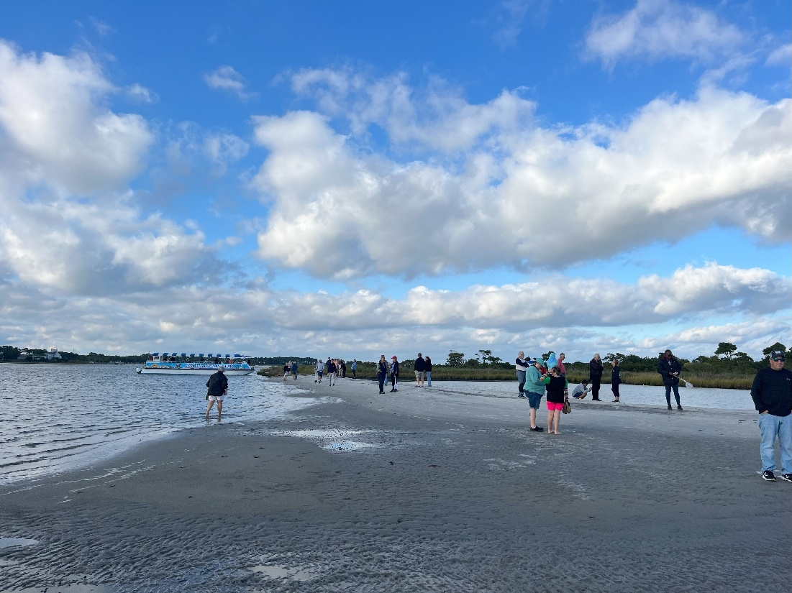

The Maryland Coastal Bays Program hosted a free boat tour to kick off our start to National Estuaries Week 2023!

On Monday. September 18th residents and staff boarded the Assateague Adventure for a tour of the bays and enjoyed conversation and a short stop onto Assateague Island.

For more information on National Estuaries Week, click on the button below.

National Estuaries Week

SepticSmart Week

The county commissioners of Worcester County have proclaimed September 18-22, 2023, SepticSmart week and urge all people on private systems to review SepticSmart educational materials and remain vigilant in maintaining their septic systems. Click on the button below to learn more.

SepticSmart

MCBP says Farewell to
Education Program Manager Chandler Joiner

  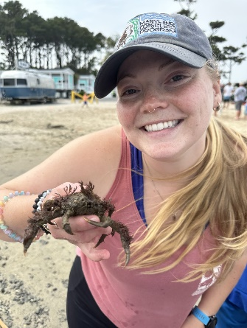
  After an incredible four years working in education at MCBP, our beloved Education Program Manager, Chandler, has gotten accepted into grad school (and accepted a new job!) in Bozeman, Montana. During her time with MCBP, Chandler was responsible for the original small-scale farmer’s project that blossomed in our successful Living Local program that continues today, she wrote countless curriculum and delivered over 400 education programs, managed partner relationships through our mini-grant program, and, most importantly, nurtured thousands of people’s curiosity and connections to the Coastal Bays watershed. As an educator, Chandler had the beautiful ability to not just listen to her audience, but to learn from them and adapt her programs based on their needs, questions, and reflections.
  It is always the most impressive when a coworker doesn’t just have a high caliber work ethic and professionalism, but when they encourage other employees to do the same through their actions, positive outlook, and personality. And Chandler has done just that. It has been an honor working with her, and we could not be more excited to see what she does in the future!

A message from Chandler:

One of the primary goals of environmental education is to help foster a sense of place. This phrase, sense of place, is used when discussing the feelings or perceptions a physical space can evoke, particularly those characteristics that make a place special or unique.

Prior to moving to Berlin, I was working for a law firm in Memphis, and I am willing to admit I had completely lost my sense of place. I discovered the Chesapeake Conservation Corps at just the right time to completely change my life. I am happy to report that after four years of marsh mucking, bay hopping, and estuary exploring, I have rediscovered a sense of place in our Coastal Bays watershed.
want to thank every single person who I worked with throughout my time with MCBP. Thank you for helping a "come here" feel welcome in this wonderful watershed. I was truly embraced, and I could not be more thankful for the lessons I learned and the love I felt. I encourage you all to continue supporting MCBP in any capacity you can, there are a lot of amazing people doing great work that frequently goes unseen.
Every one of us plays an important role in making our community a welcoming place for all. Let this goodbye note serve as a reminder to say hello to your neighbor, support a local farmer, take time to play outside, and of course... volunteer for your local environmental organization 😉
Thank you for everything!

MCBP Welcomes Chesapeake Conservation and Climate Corps Kelsey Poisol

  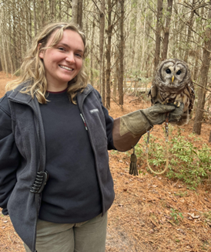
  Welcome to Kelsey Poisol as our Chesapeake Conservation and Climate Corps Member for the next year!
  In 2022, she graduated from Salisbury University with dual degrees in Environmental Studies and Biology. After graduation, she worked with the MDNR on freshwater mussel surveys and biological stream surveys. For the past ten months she worked at Assateague State Park as a member of the Maryland Conservation Corps, participating in conservation projects, environmental education, and care of the ambassador animal collection.
  Although she is originally from Carroll County, these past few years on the shore have sparked her passion for local wildlife and ecosystems. She’s particularly interested in bivalves and birds of prey. She’s excited to explore the coastal bays this year and participate in a wide range of research projects!

Discover Your Watershed

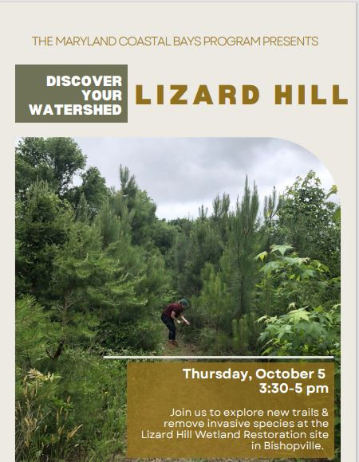

Register Here



Tern Raft Update

  Our final number of nests this season was up to 322 nests! Last year this number was 155. 322 nests is a BIG deal.
  Historically, before Common Terns became Maryland state endangered (with less than 30 nests in the coastal bays,) we had breeding pair counts of up to 900-1,000 Common Terns each year.
  322 means in three years we have recovered one third of the population. They will now begin their journey to South America for the winter. Here are two recent photos of a newly fledged chick and sunset out at the raft.
  This project is a collaboration between MCBP, Maryland Department of Natural Resources (DNR), and Audubon Mid-Atlantic.
  Photos by Bird Habitat Coordinator Kim Abplanalp
  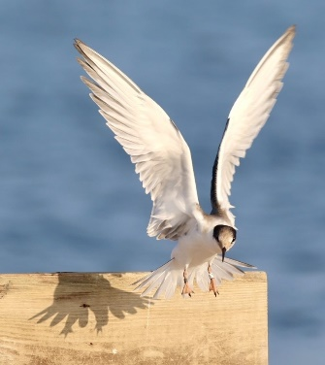
  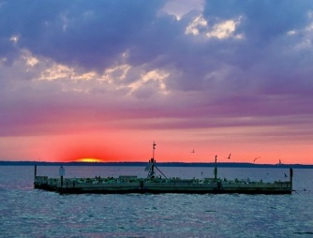

In the News

Check out the WRDE news coverage of National Estuaries Week

Click Here

Listen to the latest podcast of Assateague Voices

Apple Podcasts
Spotify

Marine Debris Plunder - Save the Date!

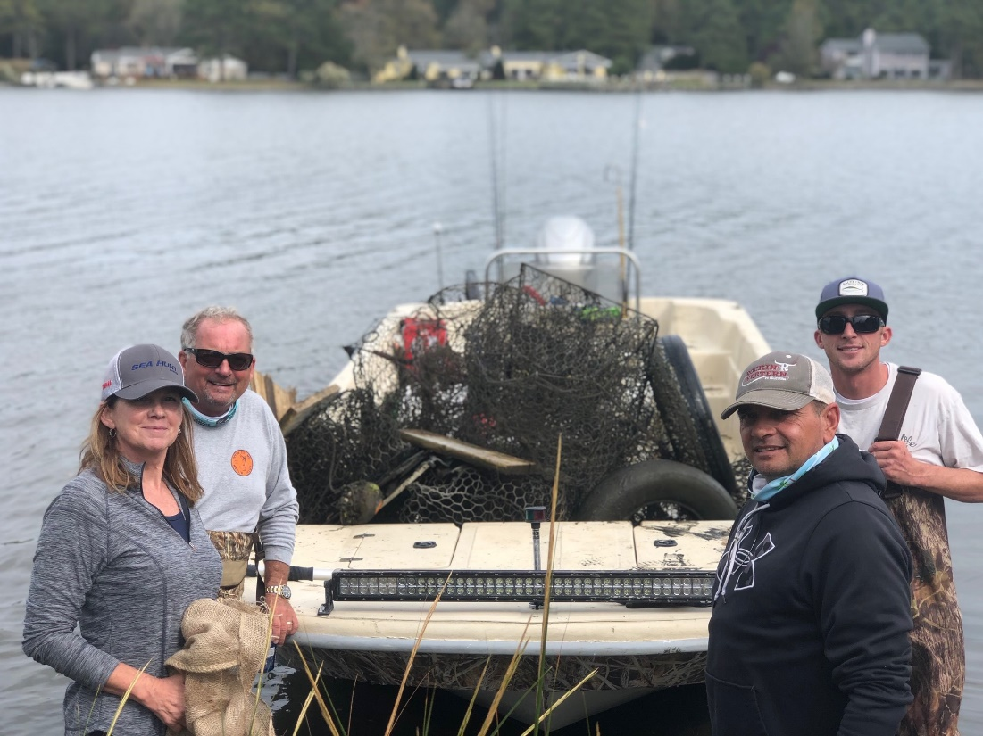

Mark your calendar for Sunday, October 22 and join Captain Jack Sparrow and Maryland Coastal Bays for another Marine Debris Plunder!

The Marine Debris Plunder is an annual debris clean up by boat or by land. This year Orsted is joining the event and will be sponsoring a Captain's Meeting the night before the event.

Orsted has also made a commitment to organize and pay watermen over the winter to pull abandoned crab pots. Check out this spring's promo on the current program and we'll be posting details on this event as they unfold!

Marine Debris Plunder Promo

8219 Stephen Decatur Highway
Berlin, MD 21811
US
If you would no longer like to receive email from us, click here to unsubscribe

