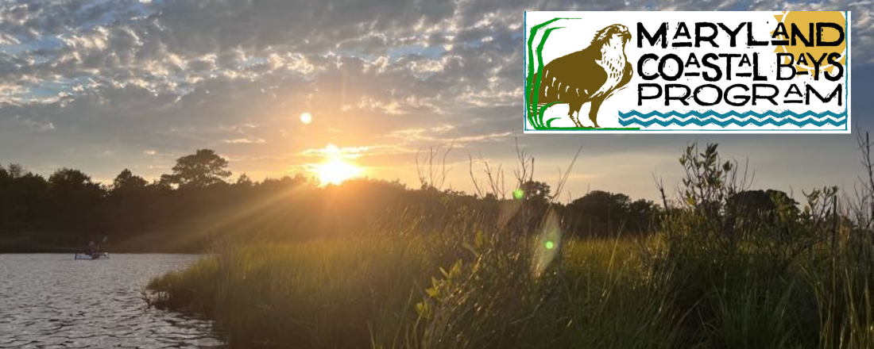

April Newsletter

Notes from the Director

Dandelions and Terns – Two Harbingers of Spring

“Simple and fresh and fair from winter’s close emerging,
As if no artifice of fashion, business, politics, had ever been,
Forth from its sunny nook of shelter’d grass,
Innocent, golden, calm as the dawn,
The spring’s first dandelion shows its trustful face.”
- Henry Wordsworth Longfellow
I’m particularly fond of Wordsworth’s disregard for fashion, business and politics when spring finally decides to emerge. All those other topics become mere distractions when the world begins busting forth with cherry blossoms, spring wildflowers and yes, even dandelions.
Here at the Maryland Coastal Bays office, we are busting forth as well. Our office, shop, and yard are a bustle of activity this time of year with water quality monitoring, trail maintenance, and environmental education classes well under way. But nothing is as pressing as the birds. Specifically, our colonial nesting bird species like terns and skimmers.
The artificial nesting raft, which was fashioned by two local craftsmen, needs to be out on the water by next week if we want the birds to find and make use of the raft to raise their chicks. The terns, which are coming from as far away as Argentina, will be looking for appropriate nesting sites and unfortunately, there aren’t many natural areas left that are suitable. And that is why the raft is so important. Last year the common terns raised approximately 150 chicks at the raft.
Nesting black skimmers, common terns and royal terns have experienced a severe decline in nesting success in the Coastal Bays over the last 20 years. We’ve seen a 90% decline in these species and it’s primarily due to a lack of sandy islands where these birds prefer to nest. The loss of suitable nesting habitat is due to a mixture of factors including sea level rise, erosion, and a lack of sand supply to fortify and augment the natural island habitats. The artificial nest is not a long-term solution to the problem but more of a stop gap measure to keep the nesting population in the area. In the meantime, we’re working on more sustainable, long-term solutions to restore island habitat and improve the nesting population of colonial waterbirds.
More on that in an upcoming newsletter. But for right now, we’ve got some work to do to get the nesting rafts ready for deployment in the Coastal Bays. Let’s hope we have the same kind of success that we had last year. We’ll keep you posted.

Kevin

  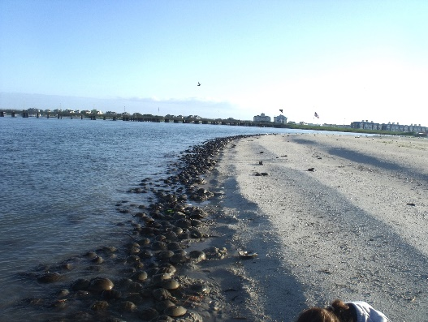
  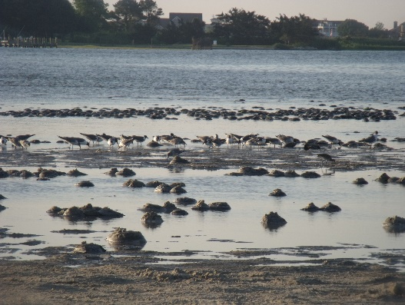
  Stranded Spawning HSC Volunteer Program
  The Maryland Coastal Bays Program is looking for dedicated volunteers to join the Stranded Spawning Horseshoe Crab Recovery Team! Volunteers will be responsible for routinely checking popular spawning grounds to rescue stranded or flipped horseshoe crabs during the spawning season from May to July. Volunteers will be required to attend a training session in late April or early May at the Sarbanes Center. The training will include information about how to safely handle horseshoe crabs, how to fill out the data sheet and the importance of horseshoe crabs. The volunteer program helps prevent mass casualties of horseshoe crabs and helps us to better understand stranding patterns and locations throughout the Coastal Bays. For more info click here
  If you have any questions regarding the volunteer program, please contact Erin Keeley at ekeeley@mdcoastalbays.org. To volunteer for this program please register.

  Planting Native Doug Tallamy
  The Maryland Coastal Bays Program and the Lower Shore Land Trust are excited to announce an upcoming speaker event, “Planting Native: How to Bring Nature into your own Backyard,” featuring Doug Tallamy, T. A. Baker Professor of Agriculture in the Department of Entomology and Wildlife Ecology at the University of Delaware. The event is scheduled to take place on Friday, April 14, 2023, at the Ocean City Golf and Yacht Club, located at 11401 Country Club Drive in Berlin, Maryland.
  This informative event is open to the public, but registration is required, as seating is limited. While the event is free, donations are accepted.
  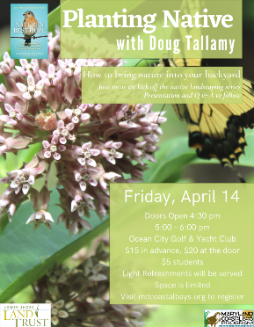

  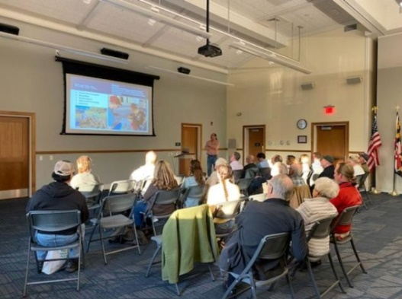
  Saltmarsh Meetings
  MCBP, U.S. Fish & Wildlife Service (USFWS), Lower Shore Land Trust (LSLT), and Mid-Atlantic Audubon Society hosted two separate meetings for saltmarsh landowners. hosted two saltmarsh meetings.
  The purpose of these meetings was to inform saltmarsh landowners in the

watershed about the work our organizations are doing, discuss the current health and state of oursaltmarshes, and begin developing relationships with saltmarsh landowners.

MCBP is looking forward to working with landowners to preserve and protect their marshes.

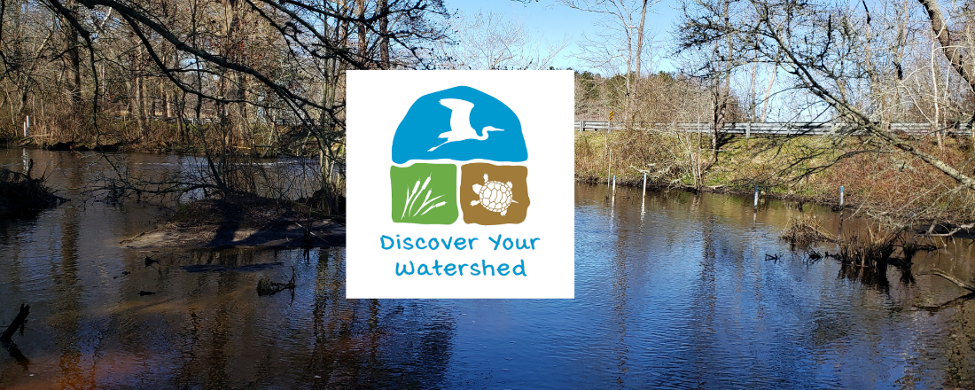

Discover Your Watershed - April 15th

Join MCBP for our April Discover Your Watershed volunteer event! This DYW will take place on Saturday, April 15th from 10:00 – 11:30 AM at the Lizard Hill Wetland Restoration Site in Bishopville, Maryland. Volunteers will be removing invasive wisteria and metal tree cages from the property. This event requires physical activity and walking across uneven ground.

We ask that all volunteers wear close-toed shoes, appropriate outdoor clothing, bring their own reusable water, bug spray, and gardening gloves if they’d like to. MCBP will provide all the tools needed to remove the wisteria and tree cages including gloves and clippers, and we will bring a water jug for refilling water bottles. Volunteers will need to sign a waiver upon arrival. Just a heads up, there is no bathroom at this site.

  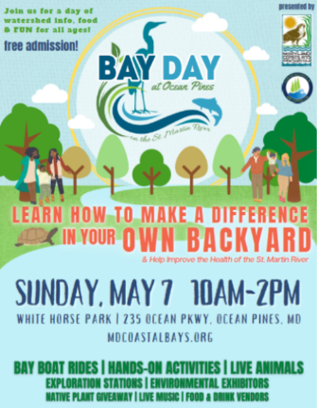
  Bay Day - May 7th
  The Bay Day recycling station will be back this year! This year we will be collecting plastic grocery bags, alkaline batteries, and e-waste (old game consoles, computers, cellphones, etc.). All of these items will be shipped off for proper recycling.
  Go Green OC will also be at Bay Day to collect compost! They can accept any type of food waste including meat, bones, dairy, fish, shells, fruit rinds, and coffee grounds - if you can eat it, they take it! Freeze your food scraps leading up to Bay Day and bring it by their exhibit table.
  For more information click here
  To volunteer at this event click here

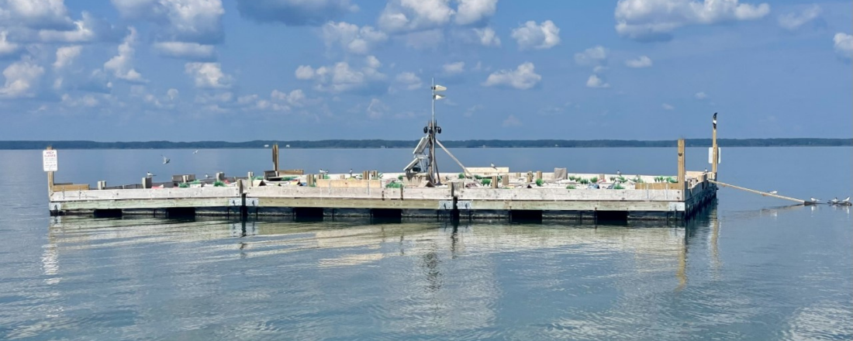

A New Season of Adventure Awaits with Our Tern Raft!

MCBP, DNR,and Audobun Mid-Atlantic, along with volunteers, will be returning the tern raft nesting platform to the bay this month and are excited to see what the new year will bring.

Last year, we ended the season with 155 Common Tern nests, a total of 181 chicks banded, 91 adults banded, and at least 140 fledglings. Plus 1 American Oystercatcher nest with 1 fledgling. That’s at least 140 new Common Terns added to the population, which for a bird with a declining population is a very nice boost!

It will be fun to see how many of the banded birds return to the platform this year! We will keep you posted!

Wetland Assessments in the Maryland Coastal Bays

  MCBP is currently planning their 5th year of assessing the health of tidal wetlands in the Coastal Bays watershed. MCBP conducts wetland assessments throughout Chincoteague, Sinepuxent, Newport, Isle of Wight, and Assawoman Bays, and on the St. Martin River. The goal of the assessments is to determine the current condition of tidal wetlands by looking at the quality of habitat, hydrology, and surrounding land use. Wetlands provide many essential services to both humans and the environment including improving water quality, providing protection from .
  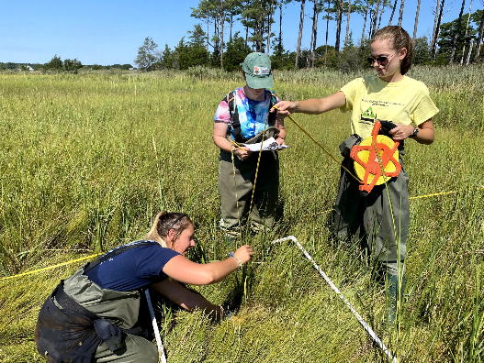

flooding and storm surges, and providing habitat for a variety of wildlife

These assessments are based on Mid-Atlantic methods and rely on maps and field visits which take less than a few hours and are a great way to look at marsh health in a rapid, “leave no trace” way. Data from the assessments are grouped by sub-watershed, so individual properties are not identified in the analysis. MCBP is reliant on the help and support of private landowners that allow access to their properties to collect this important data. These assessments help MCBP focus on tidal wetlands in need of tidal restoration and resiliency efforts.

Property owners with tidal marsh in the coastal bays watershed that wish to learn more about MCBP’s Wetland Assessment initiative, or to discuss scheduling a tidal wetland assessment should contact MCBP’s Environmental Scientist, Billy Weiland, at 410-213-2297 ext. 109, or email bweiland@mdcoastalbays.org.

8219 Stephen Decatur highway
Berlin, MD 21811
US
If you would no longer like to receive email from us, click here to unsubscribe

