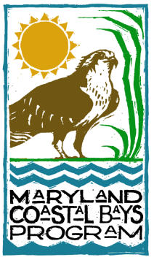
MARYLAND COASTAL BAYS PROGRAM
8219 Stephen Decatur Highway
Berlin, Maryland 21811
(410) 213-2297 - Phone
(410) 213-2574 – Fax
ctoulan@mdcoastalbays.org
www.mdcoastalbays.org

2022 Horseshoe Crab Spawning Survey Results

Carly Toulan and Katie Kavanagh, Maryland Coastal Bays Program
Steve Doctor, Maryland Department of Natural Resources,
Fisheries and Boating Services

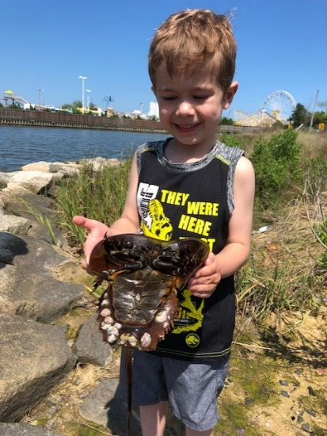
The 2022 horseshoe crab (HSC) spawning survey was the 21st annual survey to track Atlantic horseshoe crab (Limulus polyphemus) spawning population abundance in the Maryland Coastal Bays. Horseshoe crabs (HSCs) are an integral component of Mid-Atlantic estuaries and provide numerous services to the environment, economy, and human health. For example, their eggs are a vital source of protein to migratory shorebirds returning from over-wintering areas. Other Coastal Bays species such as eels, catfish, juvenile striped bass, white perch, killifish, weakfish, Atlantic silversides, bluefish, sand shrimp, blue crabs, spider crabs, and hermit crabs also depend on horseshoe crab eggs and larvae as a source of food (ASMFC, 2019). Adult horseshoe crabs are a food source for sea turtles, conch, and sharks. In commercial fisheries, horseshoe crabs are harvested for bait in whelk and eel pots. Lastly, horseshoe crabs are important to human health as their blood is used in the biomedical industry to test for the presence of bacterial toxins in various products.
A young horseshoe crab volunteer showing us how to properly hold a horseshoe crab! By volunteer Lisa Guerriero

The purpose of the annual horseshoe crab spawning survey is for the Maryland Coastal Bays Program (MCBP) and Maryland Department of Natural Resources (MDNR) to monitor abundance trends in the local population. The data collected from these surveys are also used to delineate areas of critical spawning habitat for horseshoe crabs and determine preferred spawning temperatures and peak spawning dates in the Coastal Bays. The survey data is submitted to the Atlantic States Marine Fisheries Commission (ASMFC) to help inform the management of horseshoe crabs. The AMSFC assesses the status of horseshoe crab populations along the Atlantic coast over time through surveys, research, and harvest records using combined data from Virginia, Delaware, Maryland, and New Jersey. The latest ASMFC stock assessment concluded that the horseshoe crab population in the Delaware Bay region, which includes the Maryland Coastal Bays waters, is stable (ASMFC, 2019). The results from our survey support the ASMFC stock assessment; the local horseshoe crab population abundance in the Coastal Bays also appears to be stable.

Methods
In 2022, spawning surveys were conducted between mid-May and mid-July at eight sites in the Maryland Coastal Bays by MDNR and MCBP staff and volunteers (Figure 1). Research in the Delaware Bay has shown that peak migration and spawning occurs during evening high tides (Walls et al., 2002). Horseshoe crab surveys are conducted around the new and full moon lunar cycles since high tides are amplified during this time. At each site, surveys were conducted at least twice per lunar period (LP). For our surveys, a lunar period is defined as two days before, the day of, and two days after a new or full moon. Lunar period #1 is defined by the first new or full moon of the year that occurs between May 1 and May 15. Subsequent lunar periods are determined by the dates of the new and full moons that follow lunar period #1, generally extending into July. Not all lunar periods are sampled every year. In 2022, lunar periods #2 – 6 were sampled. Occasionally, the calendar dates of lunar periods may slightly overlap from year to year depending on how early or late in May lunar period #1 is each year.
Because sampling can be uneven from year to year due to volunteer availability and weather, the counts have been standardized using a variable called count per unit effort (CPUE) to report relative abundance from year to year. Effort is defined as the number of surveys per year, and the CPUE is calculated as the number of horseshoe crabs counted divided by the number of surveys.
At the start of each survey, the water temperature was measured with a handheld thermometer or YSI Pro 2030 SCT meter and noted on the data sheet. Then, surveyors walked along a beach transect and counted all the horseshoe crabs within a 1-m width extending from the high tide waterline into the water (Figure 2). Transect length varied with location and ranged between 73 – 211 meters. Any dead horseshoe crabs spotted during the survey were tallied regardless of whether they fell within the transect area. Horseshoe crabs were tallied by sex. Male horseshoe crabs are about 25% smaller than female horseshoe crabs and have a few anatomical differences that are easy for surveyors to assess visually to determine the sex of the crab. During peak spawning, horseshoe crabs are often found in abundances of hundreds to thousands along the beaches. When this was the case, a 1m-by-1m quadrat was used to subsample the spawning population at six locations spaced evenly along the length of the beach being surveyed. The quadrat was placed down on the ground, and any horseshoe crabs that initially fell at least halfway into the quadrat were counted and sexed.
The full spawning survey protocol and methods can be found in Maryland Coastal Bays Program’s Quality Assurance Project Plan (QAPP), which was submitted to the U.S. Environmental Protection Agency in 2022.
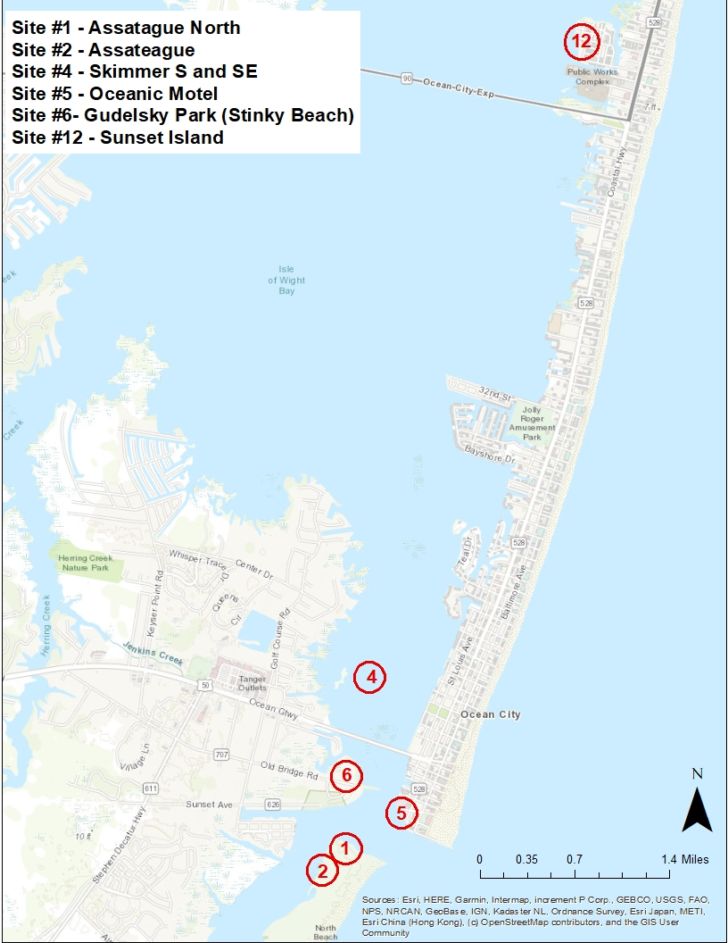

Figure 1. Maryland Coastal Bays Horseshoe Crab Spawning Survey Sites.

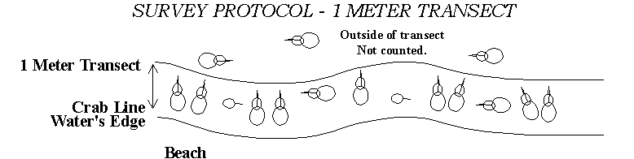

Figure 2. Diagram of methods used for surveying along a beach transect.
Results
Catch Per Unit Effort
In 2022, volunteers and staff completed 67 spawning surveys and counted 28,625 horseshoe crabs across the 8 sites. The 2022 CPUE was 427.24. This is greater than the average CPUE for 2002 – 2022 (276.36). This year’s CPUE is the greatest CPUE since 2018 and the sixth greatest CPUE recorded since surveying began in 2002 (Table 1).

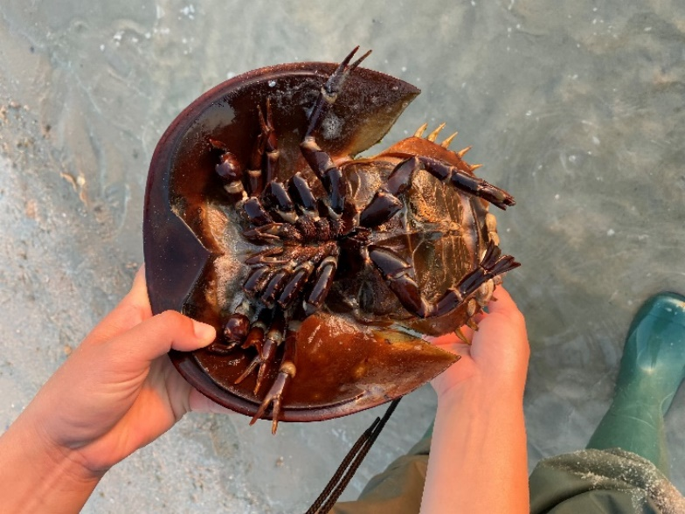
Table 1. Count Per Unit Effort of horseshoe crabs by year.
Underside of a male horseshoe crab by MCBP’s Carly Toulan.
Year | # of surveys | Total # of HSCs | CPUE
2002 | 19 | 105 | 5.53
2003 | 13 | 523 | 40.23
2004 | 53 | 689 | 13.00
2005 | 46 | 309 | 6.72
*2006 | 57 | 3918 | 68.74
2007 | 115 | 7617 | 66.23
2008 | 86 | 10690 | 124.30
2009 | 63 | 21846 | 346.76
2010 | 47 | 23438 | 498.68
2011 | 58 | 23105 | 398.36
2012 | 60 | 21127 | 352.12
2013 | 83 | 31873 | 384.01
2014 | 66 | 35278 | 534.52
2015 | 30 | 14238 | 474.60
2016 | 31 | 9095 | 293.39
2017 | 30 | 14544 | 484.80
2018 | 41 | 22140 | 540.00
2019 | 45 | 6663 | 148.07
2020 | 42 | 12228 | 291.14
2021 | 46 | 14036 | 305.13
2022 | 67 | 28625 | 427.24

*Surveys began on northern Assateague Island and Skimmer Island in 2006 and effort was increased in these areas in 2008.

Timing of Horseshoe Crab Spawning
Horseshoe crab spawning varies by latitude, but generally occurs between May and July along the Atlantic coast. Our data show the highest spawning in the Maryland Coastal Bays typically occurs in June (Table 2).

Table 2. Horseshoe crabs counted by month in the Maryland Coastal Bays.
Horseshoe crabs spawning by volunteer Lisa Guerriero

Year | May | June | July | August | Total # HSCs (live & dead)
2002 | 0 | 105 |  |  | 105
2003 | 2 | 521 |  |  | 523
2004 | 57 | 632 |  |  | 689
2005 | 48 | 261 |  |  | 309
2006 | 125 | 3,793 |  |  | 3,918
2007 | 711 | 6,636 | 270 |  | 7,617
2008 | 1 | 4,689 | 5,928 |  | 10,618
2009 | 10 | 18,627 | 3,190 | 19 | 21,846
2010 | 1,205 | 17,285 | 4,948 |  | 23,438
2011 | 5 | 15,166 | 7,934 |  | 23,105
2012 | 2,032 | 13,330 | 5,748 | 17 | 21,127
2013 | 261 | 22,875 | 8,737 |  | 31,873
2014 | 560 | 28,790 | 5,928 |  | 35,278
2015 | 38 | 7,262 | 6,938 | 0 | 14,238
2016 | 37 | 4,625 | 4,369 | 64 | 9,095
2017 | 25 | 11,040 | 3,479 |  | 14,544
2018 | 7,462 | 9,956 | 4,722 |  | 22,140
2019 | 11 | 6,315 | 337 |  | 6,663
2020 | 14 | 8,050 | 4,164 |  | 12,228
2021 | 160 | 11,718 | 2,158 |  | 14,036
2022 | 309 | 19,384 | 8,932 |  | 28,625
TOTAL | 13,073 | 211,060 | 77,782 | 100 | 302,015

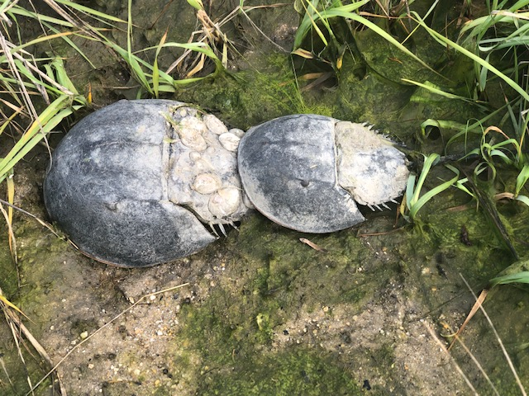

Peak Spawning

In 2022, sampling occurred during five different lunar periods from mid-May until mid-July. This year, lunar periods #2 - #6 were sampled. Most survey locations were sampled at least twice per lunar period. Assateague North was only sampled during lunar periods #4 - #6, and Skimmer West was only sampled during lunar period #4. Lunar period #6 was an additional phase added for Skimmer and Assateague sites because we noticed spawning activity continuing beyond our normal sampling period.
When looking at the CPUE during each lunar period (total number of horseshoe crabs divided by the total number of surveys in each lunar period ), peak mean spawning occurred during the sixth lunar period this year. The greatest number of horseshoe crabs counted by surveyors on a single day occurred on June 15th during the fourth lunar period (full moon +1 day). Historically, spawning typically is greatest during the fourth lunar period, which typically has been the new or full moon occurring between June 14 and June 29 (Figure 4).

Figure 3. Total number of live horseshoe crabs counted by LP in 2022.

Figure 4. Peak spawning LPS based on mean horseshoe crab abundance 2002 – 2022. Is this CPUE?

Water Temperature and Spawning
Results from surveys conducted between 2007 - 2022 show that spawning activity begins around 15°C in the Maryland Coastal Bays, and peaks between 20°C and 22°C (Figure 5). Research in the Delaware Bay supports these findings, determining the critical water temperature for horseshoe crab spawning initiation to be 15°C (Michels et al., 2010). As shown in Figure 5, low numbers of horseshoe crabs spawn around the minimum temperature threshold, however active large-scale spawning in the Coastal Bays begins around 18°C and declines once water temperatures exceed 23°C. In 2022, spawning horseshoe crabs were only found during surveys when the water temperature exceeded 16°C, except for one survey at the Oceanic Motel on May 18, 2022, where the water temperature was 12°C and 8 horseshoe crabs were counted.
As stated previously, peak spawning typically occurs during the fourth lunar period in mid- to late- June. By this time of the year, the water has warmed up, triggering greater spawning activity. Figure 6 shows the average water temperature recorded during the peak spawning lunar period of each year since 2007 when we began recording water temperatures. Peak spawning lunar periods are noted for each year on this figure, which is defined as the lunar period with the highest mean number of live horseshoe crabs in a given year. As shown in Figure 4, this year’s peak spawning LP occurred later than normal in mid-July during LP6 when the average water temperature at survey locations was 21.35 °C. Although the highest mean number occurred later in the season than usual, the water temperature at this time coincides with historic average water temperatures during peak spawning LPs which have ranged between 19.10 - 22.34 °C.
Peak spawning dates vary by site and are influenced by the proximity to the Ocean City inlet. Usually, the water warms up fastest at Sunset Island because it is located further from the Ocean City inlet where water temperatures tend to stay colder longer because of the influx of cold ocean water. Table 3 shows the peak spawning dates of each site surveyed this year as well as the water temperature recorded at the site that day. Most of the peak spawning dates for the individual sites occurred during the fourth lunar period but occurred later in the summer for the two sites on Assateague Island this year.
Figure 5: Total number of spawning HSCs found at various water temperatures from 2007 – 2022.

Figure 6. Average water temperature during peak spawning LPs (2007-2022).

Table 3. Peak spawning dates (PSDs) at individual sites and water temperatures on PSD in 2022.

Site Name | Peak Spawning Date | Temperature (°C)
Sunset Island | 6/14/2022 | 24.5
Skimmer South | 6/15/2022 | 21.3
Skimmer SE | 6/15/2022 | 21.3
Skimmer West | 6/15/2022 | 21.3
Homer Gudelsky Park | 6/16/2022 | 20.8
Oceanic Motel | 6/16/2022 | 22.0
Assateague North | 6/28/2022 | 19.5
Assateague | 7/13/2022 | 21.2

Sex Ratios of Spawning Horseshoe Crabs on Survey Beaches
In 2022, there were 3.3 males to every female crab, which is a typical ratio found in the Mid-Atlantic region (ASMFC, 2019) (Figure 7). The survey counts over the last two decades indicate male to female sex ratios have remained relatively stable, except for the 2019 survey that had an historic high M:F ratio due to a low number of females encountered (Figure 7). The overall average (2002 – 2022) sex ratio in the Coastal Bays is 3.77. For horseshoe crabs, high male to female ratio is important for maintaining genetic diversity because more than one male can fertilize a single female’s eggs. Generally, the higher the genetic diversity, the healthier the population.
The population is not highly skewed toward males, but rather the males remain on or near the spawning beaches longer than the females (Walls et al., 2002). This gives the impression that there are more males than females in the population and creates a male-biased sex ratio (Walls et al., 2002). Harvest regulations in Delaware, Maryland, and Virginia have capped the number of horseshoe crabs that can be harvested. In Maryland, beginning in 2013, the harvest of female horseshoe crabs was prohibited (Doctor et al., 2015). Our data shows that male-biased harvest regulations in recent years have not greatly affected the local spawning population’s sex ratio.

Figure 7. Sex ratios of horseshoe crabs counted in spawning surveys from 2002 through 2022.

New Location for Surveying Spawning at Assateague Island

In addition to the Assateague Island site normally surveyed every summer that is located on the bayside of the island, a new location on the northern-facing side of Assateague Island was surveyed this year (see the locations of site # 2 and #1 respectively on Figure 1). The north side of the island faces the Ocean City inlet and is currently partially protected by several jetties, but is also partially open, which allows horseshoe crabs to swim in to spawn on the beach there. There are plans in the future for the Army Corp of Engineers to connect the jetties and completely enclose the north side of the island, blocking access for horseshoe crabs to spawn on the beach. Historically, this northern site has not had much horseshoe crab spawning activity. It was sampled by MCBP and MDNR from 2006 – 2008 but has not been sampled since due to low spawning activity at this site. However, this year MCBP and MDNR noticed an abundance of spawning activity there, with horseshoe crabs present in the hundreds to thousands (Figure 8). MCBP and MDNR staff began sampling a 132 meter transect at “Assateague North” in addition to the normal 100 meter transect on Assateague during the fourth lunar period and continued to survey both locations through the sixth lunar period this summer. In total, 7,230 horseshoe crabs were counted at Assateague North while 331 were counted at Assateague this year.

Figure 8. Abundance of horseshoe crabs found at the Assateague North and Assateague survey sites during spawning surveys conducted in 2022.

Skimmer Island is Critical Spawning Habitat

Skimmer Island is located just north of the route 50 bridge in Isle of Wight Bay. Since 2008, the south and southeast portions of Skimmer Island have been surveyed for horseshoe crabs. From 2011 to 2014, Skimmer Island received about 1,000 cubic yards of dredged sand from a nearby channel to replenish area lost due to erosion. The beneficial dredge material expanded the available area for horseshoe crab spawning. However, since the last replenishment in 2014, the island has been continually eroding. The shape of Skimmer Island is dynamic and constantly changing due to wave energy, sea level rise, and erosion. This can impact where and how many horseshoe crabs are spawning on the island from year to year.

The number of surveys conducted at Skimmer Island has varied throughout the years with as many as 31 surveys in 2008. There was a total of 24 and 22 surveys conducted in 2013 and 2014, respectively, which were the years that had the highest total horseshoe crab counts at Skimmer Island (Table 4). Between 2015 and 2021, the number of surveys conducted at Skimmer has decreased to approximately 13 total surveys conducted each year on the island. Generally, the more surveys conducted, the greater the sample size. This could explain why the horseshoe crab numbers for 2013 and 2014 were so high.

In 2022 there were a total of 22 surveys conducted on Skimmer which was the greatest number of surveys conducted on the island since 2014. Over the years Skimmer Island has changed significantly in size, shape, and elevation. The island is highly influenced by erosion, wave energy, and sea level rise. In 2022, the western side of the island flooded during the LP4 high tides. This is likely the reason why there was an unusually high abundance of spawning activity on the western side of the island. In addition to the surveys conducted on Skimmer S and SE, there were 2 surveys conducted on the west side of Skimmer. High spawning activity on the western side of the island was only noticed during LP4 with over 2,000 horseshoe crabs counted between June 14th and 15th. It will be interesting to see how spawning activity changes as Skimmer Island continues to decline in size and elevation.

In total, 17,338 horseshoe crabs were counted at Skimmer Island in 2022, 15,246 of which were counted at the south and southeast transects. The CPUE by survey was calculated for each site to standardize for variability in the number of surveys conducted at Skimmer Island’s two primary survey locations each year (Table 4). The CPUEs in 2022 were 807 horseshoe crabs per survey at Skimmer south and 718 horseshoe crabs per survey at Skimmer southeast, which were very similar to CPUE values calculated in 2021.

The horseshoe crabs counted at the Skimmer south and southeast survey locations accounted for 53.26% of the total horseshoe crabs counted at all surveying locations in 2022 (Table 5). Even though the total number of horseshoe crabs counted at the Skimmer Island survey locations each year has not been as great as it was in 2014, these two locations have consistently accounted for over 50%, and usually greater than 75% of the total horseshoe crabs counted at all surveying locations since 2007. This demonstrates the importance of Skimmer Island as a spawning habitat for the horseshoe crabs in the Maryland Coastal Bays. It is important to note that although the Skimmer transects only accounted 53.26% of the total horseshoe crabs counted this year, this low value is not cause for concern. The reason for the dip in this percentage this year is not due to low spawning activity on Skimmer Island, but rather is because of the unusually high levels of spawning activity surveyed on Assateague Island this year.

Figure 9. Total number of horseshoe crabs found each year along two 100 meter transects on Skimmer Island.

Table 4. CPUE of horseshoe crabs for the south and southeast transects on Skimmer Island.
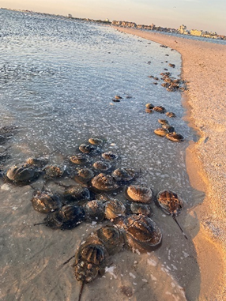
Year | Skimmer South | Skimmer SE
2006 | N/A | 764
2007 | 492 | N/A
2008 | 1315 | 153
2009 | 773 | 801
2010 | 412 | 1508
2011 | 1114 | 819
2012 | 1036 | 642
2013 | 1247 | 864
2014 | 1807 | 863
2015 | 1291 | 955
2016 | 933 | 512
2017 | 1586 | 849
2018 | 1827 | 622
2019 | 401 | 127
2020 | 939 | 355
2021 | 807 | 700
2022 | 807 | 718

Horseshoe crabs spawning on Skimmer Island by MCBP’s Carly Toulan

Table 5. Percent of Skimmer Island’s horseshoe crab counts at south and southeast transects compared to the total number of horseshoe crabs counted at all surveying locations.
Year | Skimmer S & SE  (live & dead) | All Survey Locations  (live & dead) | % of Total HSCs
2006 | 764 | 3918 | 19.500
2007 | 4916 | 7617 | 64.540
2008 | 9880 | 10618 | 93.050
2009 | 20467 | 21846 | 93.688
2010 | 23035 | 23438 | 98.281
2011 | 21265 | 23105 | 92.036
2012 | 20138 | 21127 | 95.319
2013 | 25338 | 31873 | 79.497
2014 | 29367 | 35278 | 83.245
2015 | 13474 | 14238 | 94.634
2016 | 8668 | 9095 | 95.305
2017 | 12174 | 14544 | 83.705
2018 | 19591 | 22140 | 88.487
2019 | 4218 | 6663 | 63.305
2020 | 7766 | 12228 | 63.510
2021 | 10550 | 14036 | 75.163
2022 | 15246 | 28625 | 53.261

Success of the Stranded Spawning Horseshoe Crab Recovery Team

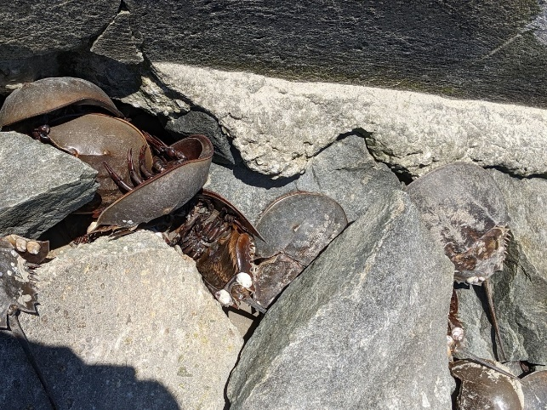
There were several hundred dead horseshoe crabs found during the 2021 spawning season in a north-south facing dead-end canal near 94th street in Assawoman Bay. It was suspected that dead horseshoe crabs floated into the canal from tide and wind currents, since they were observed in windrows outside of the canal. To explore the potential causes of dead horseshoe crabs found in these dead-end canals, this year’s Research Experience for Undergraduates (REU) students from the University of Maryland Eastern Shore (UMES) conducted a research investigation. Their findings suggested that live horseshoe crabs entered the canals and died due to the low oxygen levels existing in these areas.
High numbers of horseshoe crab strandings have similarly occurred every year on rocky outcroppings at the Oceanic Motel, Homer Gudelsky Park, and another dead-end canal on Robin Drive near Jolly Roger Amusement Park. To remediate mass horseshoe crab casualties caused by strandings, MCBP organized a volunteer group for the 2022 spawning season to help rescue stranded horseshoe crabs.
Stranded horseshoe crabs at the Oceanic Motel Beach by volunteer Robin Mower
The Stranded Spawning Horseshoe Crab Recovery Team consisted of 11 volunteers who went out a total of 67 times to rescue stranded horseshoe crabs between mid-May and late-July at three sites in the Coastal Bays during low tides. In total, 3,568 stranded horseshoe crabs were rescued, making this a successful pilot year for the program. Table 6 summarizes the results of the recovery surveys. In addition to noting the number of stranded horseshoe crabs rescued, recovery team members also recorded data on the number of dead horseshoe crabs found and number of horseshoe crabs actively spawning at the water’s edge. MCBP plans to continue and expand this program next year. If you are interested in joining this program for the 2023 season, please reach out to Carly Toulan at ctoulan@mdcoastalbays.org.

Table 6. Horseshoe crabs rescued by Stranded Spawning Recovery Team
Site Name | # of recovery surveys completed | # of stranded HSCs rescued | # of dead HSCs found
Homer Gudelsky Park | 11 | 23 | 1
Oceanic Motel | 39 | 1,486 | 369
Robin Drive | 17 | 2,059 | 149

References

Atlantic States Marine Fisheries Commission (ASMFC). (2019). Horseshoe crabs stock assessment and peer review report. http://www.asmfc.org/uploads/file/5cd5d6f1HSCAssessment_PeerReviewReport_May2019.pdf.

Doctor, S. et al. (2015). Maryland FMP Report (August 2016) Section 12. Horseshoe Crab (Limulus polyphemus).

Michels, S., Smith, D., and Bennett, S. (2010). Horseshoe crab spawning activity in Delaware Bay: 1999-2009. Report to the Atlantic States Marine Fisheries Commission’s Horseshoe Crab Technical Committee (March 26, 2010).

Walls, E.A., Berkson, J., & Smith, S.A. (2002). The Horseshoe Crab, Limulus polyphemus: 200 Million Years of Existence, 100 Years of Study. Reviews in Fisheries Science, 10(1), 39-73.

Acknowledgements: Special thanks to the volunteers, without whose help this survey would not be possible: Carol Sottili, Pam Casagrande, Susie and Ray Smith, Debbie Munford, and Laurie Lawton-Smith. Thanks also to the members of the Stranded Spawning Horseshoe Crab Recovery Team: Frank and Karen Baldwin, Marnien O’Brien, Susan Murphy, Lisa Guerriero, Ken Koroknay, Jim Spicknall, Joan Worrall, Cathey Foelber, Laurie Lawton-Smith, and Robin Mower. Finally, thanks to the UMES staff Eric May and Maggie Sexton and REU students, and Joshua Newhard at US Fish and Wildlife Service for coordinating the tagging program.

