Update by Dr. Archer Larned, Coastal Bird Habitat Conservation Coordinator
Photos by Kim Aplanalp, Field Assistant

Well, we passed 150 nests! To be exact, we now have 153 nests! There were only 4 new nests last week, compared with 15 from the previous week, so things are definitely slowing down. Lots of fledgling terns are flying around the raft now and there is a noticeable decline in the number of terns on the raft during the day. One of our banded fledglings was even spotted at the Ocean City Inlet on Friday.
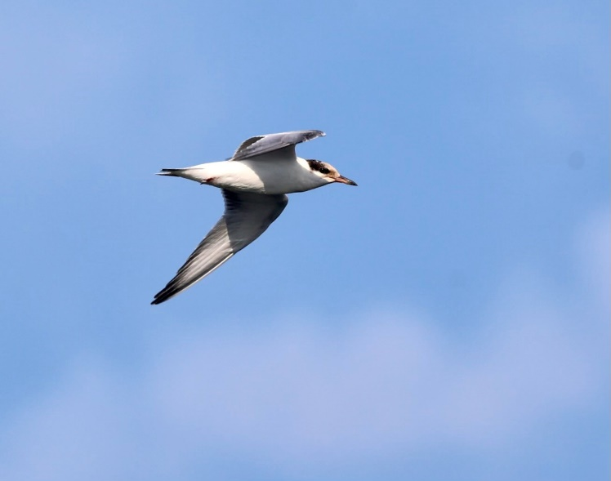

A “life-raft” and ramp have been added to the platform and are being used by adults and chicks.

We saw fledglings walking up the ramp, so it seems like it is a welcome addition to the raft.



