This month, we are featuring the words of our current president and past director Steve Taylor. Steve successfully paved the way for our program’s initial success, including the very challenging task of engaging the community and partners with a new environmental group. We are fortunate to have our past director continue to pave the way for the future of our program. Pictured here is Steve along with his wife Suzy and past president Bob Abele.
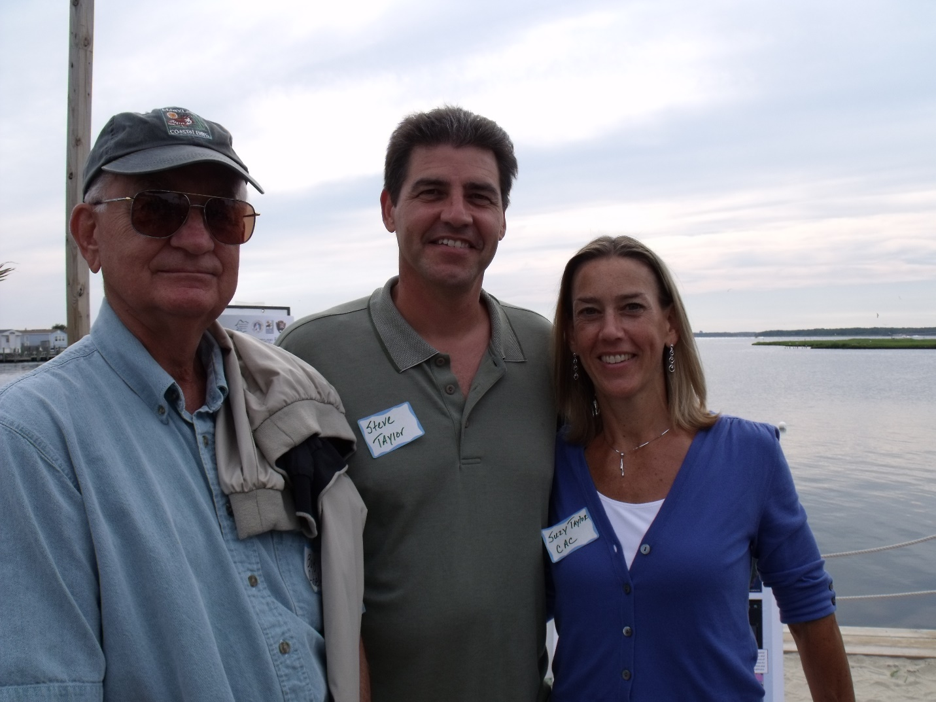

Bringing the Maryland Coastal Bays Program to Worcester County was an effort that started many years ago. In 1996, the Environmental Protection Agency (EPA) decided to expand the National Estuary Program (NEP) from 21 estuaries to 28 estuaries, so a national call for proposals was released. The key requirement for inclusion in the program was demonstrating the proposed estuary is of “national significance” because of its ecological and economic value to the nation and thus eligible for federal funding. All estuary nominations were to be submitted by State Governors thereby demonstrating a strong commitment to the restoration and protection of our most vital coastal resources.
Acceptance into the NEP was not an easy one. EPA staff were reluctant to include the Maryland Coastal Bays Program because of the significant federal investment already devoted to the Chesapeake Bay Program. EPA staff felt that federal resources should be diversified and spread to other states needing financial support for estuary protection. However, another key criterium for acceptance into the program was “likelihood of success”. It was argued that Maryland could easily achieve success due to the lessons learned from Chesapeake Bay Program efforts as well as the expertise assembled to focus on the Chesapeake.
Fortunately, Maryland’s nomination of the Coastal Bays was successful. Authors of the nomination articulated several key points such as the importance of the commercial and recreational bay fishery along with easy access to an economically important ocean fishery; the sensitivity and rarity of habitats necessary for wildlife, fish and threatened and endangered bird species; and its unique location to urban centers like Washington D.C., Baltimore, and Philadelphia for tourism and recreation opportunities. Furthermore, key scientists and resource managers involved in Chesapeake Bay efforts committed to their direct involvement in the Coastal Bays program to ensured an even greater likelihood of success.
Consequently, EPA approved the Maryland Coastal Bays Program for inclusion in the National Estuary Program and Governor Glendening tasked John Griffin, Secretary of the Department of Natural Resources, with leading the effort. He immediately assembled a diverse team of scientists and resource experts to begin planning efforts. Verna Harrison, the Assistant Secretary for DNR, worked with the Maryland Coastal Zone Management Program Director, Gwen Shultz, to orchestrate program efforts. Together they recruited the efforts of Dr. Donald Boesch from the University of Maryland Center for Environmental Science to lead the Scientific and Technical Advisory Committee (STAC) for the program. They joined forces with the Worcester County Commissioners to identify a leader for the Citizens Advisory Committee (CAC). Commissioner Jeanie Lynch recommended Carolyn Cummins, a member of the County Planning Commission due to her knowledge and expertise in local land use planning in the county. With Ms. Cummins’ acceptance and Dr. Boesch’s connections with regional scientists, the program was up and running.
Key questions for the STAC were:
- What do we currently know about the environmental condition of the Coastal Bays?
- What studies exist on water quality, fisheries, habitat diversity and anthropogenic behaviors?
- What information is needed to better understand the condition and recent environmental changes?
- What analysis is needed to direct policy improvements for this sensitive ecosystem?
Key questions for the CAC were:
- What knowledge can be shared by those living in the watershed with scientists and resource managers to better understand local environmental conditions and potential policy changes?
- How can local planning help improve and protect environmental conditions?
- How can county citizens participate in efforts to improve and protect the local environment?
- What changes will be necessary for long-term environmental improvements?
While these important questions were being developed, a search was underway for the Maryland Coastal Bays Executive Director. Leaders were seeking someone with knowledge of the National Estuary Program and natural resource management to fill this important role. Fortunately, they found the ideal candidate at EPA and Steven Taylor was hired in 1997 to direct the program through the scientific discovery and 3-year action plan development phase of the process.
Steve was asked, “What was the most challenging part of starting the new program.” He replied, “99% of the time, everyone agreed with the recommended environmental actions, but 1% of the time, it was full-on war!” Consensus building results in the best possible product but getting there can certainly be tumultuous. Participants would feel strongly about their idea or opinion and if it is challenged, sometimes sparks would fly. At one point, Steve was berated by an elected official and he simply replied, “This is what your constituents want, do you not want that too?” Suddenly, the problem was no longer an issue. Steve said his best advice during difficult times would often come from Carolyn Cummins who would simply say, “Steve, you’re doing great, just keep moving forward.” And so he did!
Since that time, the Coastal Bays Program has accomplished a great deal. Very little was understood about the environmental condition of the ecosystem in 1997. But, now extensive environmental monitoring and resource evaluations allow decision makers to pinpoint specific actions that restore degraded areas and preserve our pristine critical natural resources. Each year the program releases an environmental report card to summarize key environmental successes and the resource challenges that lie ahead.

